Moray Chamber of Commerce

**Annual Business Awards**

**Most Promising Enterprise Award**

Application Form

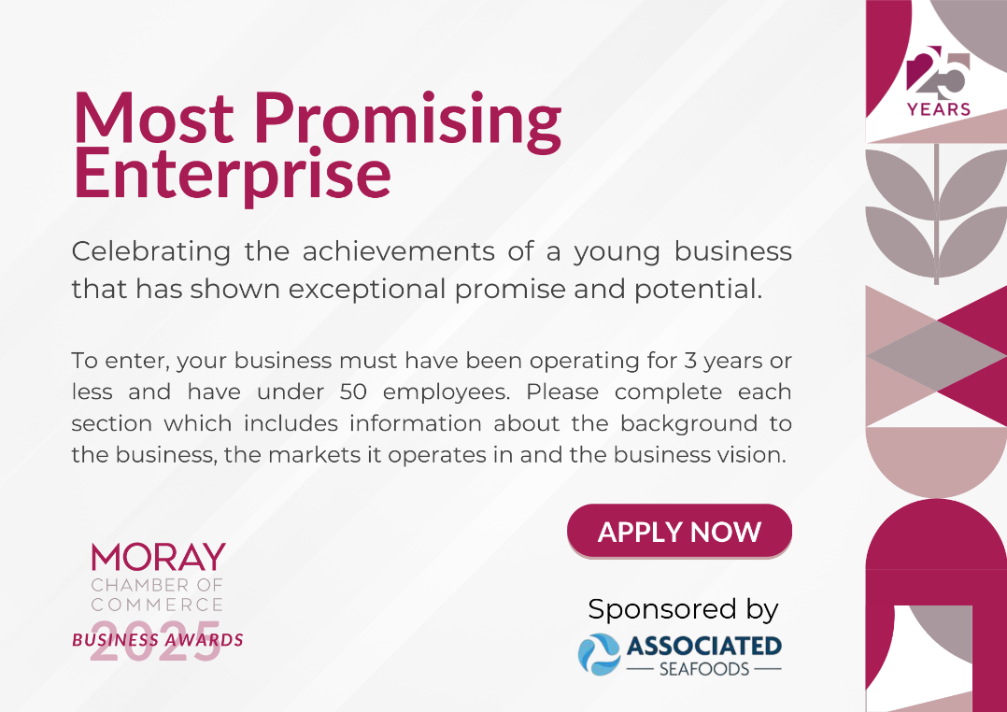

Please submit to: [**info@moraychamber.co.uk**](mailto:info@moraychamber.co.uk?subject=Business%20Awards%20Application%202025:%20Export%20Award)

Closing date: **Friday 3rd October 2025 at 5pm**

The winner will be announced at the **Annual Business Awards evening** at the Laichmoray Hotel, Elgin on Wednesday 10th December 2025.

|  |  |
| --- | --- |
| **Company Name:** |  |
| **First Name:** |  |
| **Last Name:** |  |
| **Email Address:** |  |
| **Phone:** |  |
| **Name of Nominee:** |  |
| **Nature of business:** |  |

|  |
| --- |
| **Please give a brief overview of your reasoning:** |
|  |
| **Please use this space for any other comments:** |
|  |

**Application Guidelines**

Moray Chamber of Commerce is proud to present the Annual Business Awards 2025. The awards provide an opportunity for businesses across the region to promote their achievements and for the business community to celebrate their success. Past winners have ranged from small local businesses to internationally renowned brands – regardless of size, all of them share a common passion for innovation and a flair for enterprise. Applications are open to members and non-members of Moray Chamber of Commerce.

**How to enter**

It is FREE to enter, and you can either apply yourself or recommend a third-party business. Complete the application form and send to [**info@moraychamber.co.uk**](mailto:info@moraychamber.co.uk) by Friday 3rd October 2025 at 5pm.

**Judging**

Our judging panel consists of representatives from the Chamber Board and award sponsors. Winners will be announced at the Moray Chamber of Commerce Annual Business Awards evening on Wednesday 10th December 2025 at the Laichmoray Hotel, Elgin.

**The Rules**

1. The awards are open to **all** businesses in the Moray & Speyside areas.
2. Applications can be made for more than one category.
3. Judges must declare an interest should they have links with any nominees.
4. Finalists and winners are invited to participate in interviews and photo shoots.
5. Moray Chamber of Commerce reserves the right to not make an award in any category if no satisfactory nominations are received.
6. Previous recipients of an award may apply.
7. The closing date for entries is 5pm, Friday 3rd October 2025.
8. The judges’ decision is final.

**