Moray Chamber of Commerce Export Award Sponsored by Highlands and Islands Enterprise
Application Form

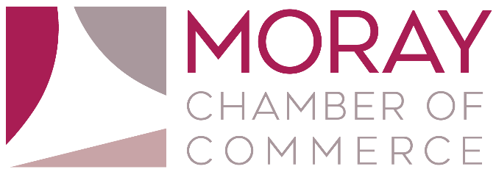

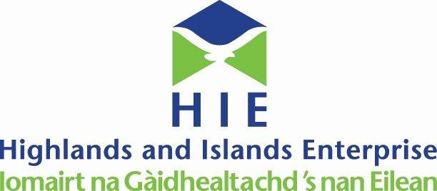

The Moray Chamber of Commerce Export Award is open to businesses with a strong track record of exporting over the last 12 months.

Please submit to cmcdonald@moraychamber.co.uk
Closing date for submitting application forms is 5pm, Wednesday 13th November 2019.
The winner will be announced at the Moray Chamber of Commerce Annual Awards Lunch at The Mill House Hotel, Buckie on Wednesday 4th December 2019.

Section 1. Business Details

Full trading name of business:
Registered name if different from above:
Date business established:
Address:
Telephone:
Website:
Main contact name and position:
Name of person submitting application:
Email:

Type of Company

Public □ Private □ Sole Trader □ Multi-National □ Other □

Provide a brief description of the business, the products or services it supplies, customers and the markets in which it operates (Approx. 200 words). Continue on a separate sheet if necessary.
What level of export sales growth have you achieved over the last 12 months? (Approx. 500 words).
Continue on a separate sheet if necessary.
Which new markets have you entered in the last 12 months? (Approx. 500 words)
Continue on a separate sheet if necessary

Has your export sales growth resulted in increased employment? (Approx. 200 words).
Continue on a separate sheet if necessary.

Authorisation

Name:
Position:
Date:

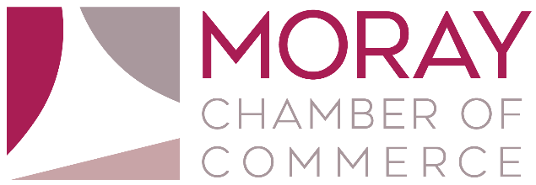

Application Guidelines

Moray Chamber of Commerce is proud to present the Annual Business Awards 2019. The awards provide an opportunity for businesses across the region to promote their achievements and for the business community as a whole to celebrate their success. Past winners have ranged from small local businesses to internationally renowned brands – regardless of size, all of them share a common passion for innovation and a flair for enterprise. Applications are open to members and non-members of Moray Chamber of Commerce.
How to enter

It is FREE to enter and you can either apply yourself or recommend a third party business. Contact Callum McDonald at cmcdonald@moraychamber.co.uk and complete the application form and send back to Callum by 5pm Wednesday 13th November 2019.

Judging

Our judging panel consists of representatives from the Chamber Board and award sponsors. Winners will be announced at the Moray Chamber of Commerce Annual Awards Lunch on Wednesday 4th December 2019 at The Mill House Hotel, Buckie.

The Rules
1. The awards are open to all businesses in the Moray & Speyside areas.
2. Applications can be made for more than one category.
3. Completed forms must be signed.
4. Judges must declare an interest should they have links with any nominees.
5. Finalists and winners are invited to participate in interviews and photo shoots.
6. Moray Chamber of Commerce reserves the right to not make an award in any category if no
satisfactory nominations are received.
7. Previous recipients of an award may apply.
8. The closing date for entries is 5pm, Wednesday 13th November 2019.
9. The judges’ decision is final.

