Most Promising Enterprise Award Sponsored by Business Gateway

Application Form

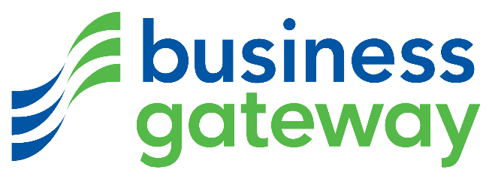

To enter, your business must have been operating for 3 years or less and have under 50 employees. Please complete each section which includes information about the background to the business, the markets it operates in and the business vision.

Please submit to cmcdonald@moraychamber.co.uk

Closing date for submitting application forms is 5pm, Wednesday 13th November 2019.

The winner will be announced at the Moray Chamber of Commerce Annual Awards Lunch at The Mill House Hotel, Tynet on 4th December 2019.

Section 1. Business Details
Full trading name of business:
Registered name if different from above:
Date business established:
Address:
Telephone:
Website:
Main contact name and position:
Name of person submitting application:
Email:

Type of organisation and sector (X all that apply):

 | Creative Industry
 | Food & Drink |  | Limited Company
 | Life Sciences |  | Partnership
 | Manufacturing |  | Social Enterprise
 | Renewables |  | Sole Trader
 | Retail
 | Service |  | No. of Employees

Please give a brief overview of your business including details of your customers, the products and/or services that you supply to them and the markets in which you operate.
Max 150 words.

Section 2. Category Questions (As a guide, TOTAL word count for Q1 to Q4 shouldn’t exceed 1000)

Q1
Please summarise why you decided to start your own business and what your vision is for your business?

Q2
Please outline the overall trend in your sales turnover and profit, together with a description of how your business has developed / grown since you started trading.

Q3
Please highlight your business aspirations and how you might achieve them over the next 3 years.

Q 4
What makes your business stand out from the competition and why you think your business should win ‘Most Promising Enterprise’ Award?

Authorisation

Name:
Position:
Date:

Application Guidelines

Moray Chamber of Commerce is proud to present the Annual Business Awards 2019. The awards provide an opportunity for businesses across the region to promote their achievements and for the business community as a whole to celebrate their success. Applications are open to members and non-members of Moray Chamber of Commerce.

How to enter

It is FREE to enter and you can either apply yourself or recommend a third party business. Contact Callum McDonald via email at cmcdonald@moraychamber.co.uk with the completed application form, by 5pm on Wednesday 13th November 2019.

Judging

Our judging panel consists of representatives from the Chamber Board and award sponsors. Winners will be announced at the Moray Chamber of Commerce Annual Awards Lunch on Wednesday 4th December 2019 at The Mill House Hotel, Buckie.

The Rules

1. The awards are open to all businesses in the Moray & Speyside areas.
2. Applications can be made for more than one category.
3. Completed forms must be signed.
4. Judges must declare an interest should they have links with any nominees.
5. Finalists and winners are invited to participate in interviews and photo shoots.
6. Moray Chamber of Commerce reserves the right to not make an award in any category if no
satisfactory nominations are received.
7. The closing date for entries is 5pm, Wednesday 13th November 2019.
8. The judges’ decision is final.

